**SMART MEDIBOX**

PROJECT REPORT

Submitted by

**ABISA M:PRN18EC002**

**AKHILA JOY:PRN18EC005**

**KALYANI MJ:PRN18EC029**

**POOJA JEEVAN:PRN18EC033**

to

the APJ Abdul Kalam Technological University

in partial fulfillment of the requirements of the award of the Degree

of

*Bachelor of Technology*

*in*

**Electronics and Communication Engineering**



**January 2022**

**Department of Electronics & Communication Engineering**

**(NBA Accredited)**



**College of Engineering, Perumon**

**Perinad p.o Kollam**

**691601**

**COLLEGE OF ENGINEERING PERUMON**

DEPARTMENT OF ELECTRONICS AND COMMUNICATION ENGINEERING

*PERINAD P.O KOLLAM – 691601*



**CERTIFICATE**

*Certified that this is a report of the project topic titled* **“SMART MEDIBOX**”*–An IOT Enabled Patient Assisting Device submitted on its successful completion by* ***ABISA M, AKHILA JOY, KALYANI M J, POOJA JEEVAN*** *under our guidance towards the partial fulfilment for the award of the Degree of bachelor of technology in Electronics and Communication Engineering of the APJ Abdul Kalam Technological University during the year 2021 –2022.*

|  |
| --- |
| *Head of the Department:*  *Dr.V Praseeda Lekshmi*  *Professor in ECE*  *CE Perumon* |

|  |
| --- |
| *Guided By:*  *Surjith S*  *Assistant Professor in ECE*  *CE Perumon*  *Ms.Smrithi V*  *Assistant Professor in ECE*  *CE Perumon* |

**DEPARTMENT OF ELECTRONICS AND COMMUNICATION**

**ENGINEERING**

**VISION**

• To mold high quality promising and creative engineering professionals in the field of

electronics and communication for better living and the future of the global society.

**MISSION**

• Create a unique learning environment to equip students to excel in technical, personal and

social life to emerge as a professional.

• Establish research and innovative culture to suit the needs of the society.

ACKNOWLEDGEMENT

The project stands complete only by dedicating sincere gratitude to those few who have contributed a lot towards the successful completion of it.

First and foremost, we praise and thank GOD ALMIGHTY for the spiritual support and blessings bestowed on us throughout our project, which made it a success.

We would like to express our sincere thanks to our principal **Dr. Z A Zoya** for rendering us all the facilities for the project.

We would like to extend our sincere thanks to the Head of our department, **Dr.V Praseeda Lekshmi** for her constant and dedicated service to brighten our career.

We express our heartfelt thanks to our project coordinators **Surjith S**, Assistant Professor in ECE, **Ms.Smrithi V**, Assistant Professor in ECE, for their valuable suggestions and support and all other faculty members for their invaluable guidance.

We wish to express our deep sense of gratitude to our parents, friends and all our well-wishers who have directly or indirectly contributed a lot towards this project.

**ABISA M****(PRN18EC002)**

**AKHILA JOY(PRN18EC005)**

**KALYANI MJ(PRN18EC029)**

**POOJA JEEVAN(PRN18EC033)**

**DECLARATION**

I undersigned hereby declare that the project report “**SMART MEDIBOX**”, submitted for partial fulfilment of the requirements for the award of degree of Bachelor of Technology of the APJ Abdul Kalam Technological University, Kerala is a bonafide work done by me under supervision of Mrs. **Surjith S** (Assistant Professor in ECE) and Mrs.**Smrithi V** (Assistant Professor in CSE). This submission represents my ideas in my own words and where ideas or words of others have been included, I have adequately and accurately cited and referenced the original sources. I also declare that I have adhered to ethics of academic honestly and integrity and have not misrepresented or fabricated any data or idea or fact or source in my submission. I understand that any violation of the above will be a cause for disciplinary action by the institute and/or the University and can also evoke penal action from the sources which have thus not been properly cited or from whom proper permission has not been obtained. This report has not been previously formed the basis for the award of any degree, diploma or similar title of any other University.

Place :

Date :

ABISA M

AKHILA JOY

KALYANI MJ

POOJA JEEVAN

**TABLE OF CONTENTS**

|  |  |  |
| --- | --- | --- |
|  |  | PAGE NO. |
| ABSTRACT |  | 6 |
| CHAPTER 1 | INTRODUCTION | 7 |
|  | BLOCK DIAGRAM | 8 |
| CHAPTER 2 | LITERATURE SURVEY | 9-10 |
| CHAPTER 3 | METHODOLOGY | 11-13 |
| CHAPTER 4 | CONCLUSION | 14 |
|  | REFERENCES | 15 |

LIST OF FIGURES

**ABBREVIATIONS**

Iot - internet of things

Imot - internet of medical things

Lcd - liquid crystal display

Led - light emitting diode

Rtc -real time clock

Sms-short message service

Gsm - Global System for Mobile communication

Gprs -General Packet Radio Services

Spo2- Oxygen saturation

Bpm - beats per minute

**ABSTRACT**

Many of old people live alone and suffer from disability, making it harder to take care of themselves. The health and wealth are critical to human society and as such should be one of the first to receive the benefits of upcoming technologies like IOT. One such attempt is made to design a multipurpose intelligent device named MEDIBOX - IOT Enabled Patient Assisting device which helps the patients take their medications at the right time. This box is a proficient system which maintains the parameters like temperature and humidity in a controlled ran recommended by the drug manufacturer and thus maintains the quality of the medicines. MEDIBOX takes control on alerting patient to take medicines, by giving buzzer alert and led indication for right medicines, avoids wrong medications at wrong time. And also confirms the medicine taken by patient with timings, if patient avoids taking medicine at correct time it sends IOT alert to care taker in order to take control over that situations confirms patients from not to skip medicine.It also has the health monitoring sensors like pulse oximeter and temperature sensors. The emergency button given will help the patient to call the caretaker easily. The locking system given will provide more security and privacy. AnIOTserver like Thinkspeakplatform is used to store the data of the patients.An application is also developed to store the details of patient like which are the medicines they are taking,time which they taken the medicine etc.

**CHAPTER 1**

**INTRODUCTION**

Now a days, healthcare monitoring by 24x7 needs a huge cost and manpower. In today’s life, human beings facing difficulty to keep in mind of the medicines they required to take. With such a large amount of prescribed medicine, the probability of forgetting to take medications at a particular time and amount prescribed is high. Some of the Internet of Medical Things (IOMT) is connected to IOT networks to monitor the day-to-day activities of the patients. Recently, there has been an attempt to design and model new medical devices which monitor the patients and help aged people for a better assisted living.

The design of an IOT Enabled Patient Assisting device is introduced. One such attempt is made to design a multipurpose smart device named SMART MEDIBOX which helps the patients take their medications at the right time. The ideal opportunity for the following tablets is shown in an LCD (Liquid Crystal Display) screen and messages are sent when the time comes to, alongside LED flickering implying which compartment to open. At the point when a compartment is opened by the patient, this is identified by a sensor and patient has taken the medicine. This box is a proficient system which maintains the parameters like temperature and humidity in a controlled range recommended by the drug manufacturer and thus maintains the medicines.

The Smart MediBox- IOT Enabled Patient Assisting device can be used by either the patient or even by nurses who are taking care of a patient or older people. The MediBox contains separate portions that can be aligned for different user’s needs. Smart MediBox helps the caregiver by specifying the required medicine quantity, the exact time to take the medicine each day.

Regular medication containers could be updated programmed multi-medicine update and gadget for simplicity of activity and ease to use. The proposed model of SMART MEDIBOX –an IOT Enabled Patient Assisting device medicine reminder is designed with the help of a micro controller. This micro controller is used to keep track of when a patient should take his/her medicines. An application is also developed for tracking patient medication details.

**CHAPTER 2**

**LITERATURE SURVEY**

1. **A Modern health monitoring care system using IoT and android (2016)** (Gipsa Alex, Jezna G Jose, Benitta Varghese, AlbyMol Abraham): Health IOT thus helps the hospital authorities to have continuous monitoring on the patients as well as it reminds the patient to have the medicines on time. So the doctor can have direct view over his patients by this. Thus the medication procedures can be shifted from hospital centric to home. It does not provide security. It has no messaging system.
2. **A health-IoT platform based on the bios- ensor and intel- ligent medicine box (2017)** (Priti Bedmuttha, Nisha Jain, Yamini Thigale, Satyajit Gargori, Prof. T.R. Pati) : It is an IoT-based intelligent home-centric healthcare platform (iHome system), which seamlessly connects smart sensors attached to human body for physiological monitoring and intelligent pharmaceutical packaging for daily medication management. Always need wifi connection.
3. **Smart Medicine Box for Patient Using NFC (2017)** (Sana Ansari, Amrut Jagtap, Geetanjali Golande) : Implemented smart medicine box using NFC tag which helps to old practice as well and also applying data mining technique for predicting disease using patient’s symptoms. Providing health reminder in day to day busy life. It has no sensor. It is not portable. Because of less battery backup.
4. **Smart Medicine Dispenser (SMD) (2018)** (Wissam Antoun, Ali Abdo Suleiman Al-Yaman, Abdallah Kassem, Mustapha Hamad Chady El-Moucary) : The major point is SMD. Elderly patients, especially ones with chronic and periodic medicine, will benefit the most for the SMD, since it will greatly increase their medicine adherence which will insure better treatment effectiveness or even save their lives. No cooling system. Less pill container.
5. **IoT Enabled Assisting Device for Seizures Monitoring (2019)** (G. Lavanya,S. Monika,G. Sandra Karunya, A. Mathan Gopi, D. Rajini Girinath ): It helping a patient totally with a conse- rvative and easy to understand way. It reminds the patient to devour the meds and gives a reasonable stockpiling condition to the medications. Capacity of prescriptions consumption subtleties can help the specialist for future references. It does not provide privacy. It has no health sensors.
6. **A smart medicine box for medication management using IoT (2020)** (S. Anandhapadmanaban, A. Ashifa, S. Sanjay Kumar, R. Suryalakshmi): IoT based smart medicine box designed with embedded system to overcome the holes of elder patient’s ambient living. The Wi-Fi connected box transfer the daily activities of the respective patient’s health details and their medication details added with benefit of GSM mode alert SMS. This box design comforts the people to take the drugs at right dose at right time. It does not provide privacy and security.
7. **Ibox: smart medicine box with IoT application (2020)** ( Nur Zulaikhah Nadzri, Yusman Yusof, Ahmad Firdaus, Ahmad Fazil): It presented the method of integrating the IoT into the medicine box. This could become a guideline for anyone especially who is new in applying the IoT. By applying the IoT concept, a real time reminder and notification can be created in assisting user for his medicine taking routine. It has no cooling system and health monitoring sensors.
8. **Medibox -IoT enabled patient assisting device (2021)** (Abdul Azeem K,Ajay M, Vengetesh M, Dr.G.Saravanavenkatesh): It aims at assisting a patient completely with a compact and user- friendly manner. It reminds the patient to consume the Medications and provides a suitable storage condition for the drugs. Storage medications intake details can assist the doctor for future references. It has no more sensors. It does not provide privacy and security. It has no pill counter setup.

**CHAPTER 3**

**3.1 BLOCK DIAGRAM**

**3.2 CIRCUIT DIAGRAM**

**CHAPTER 4**

**METHODOLOGY**

**1. MICROCONTROLLER**

Arduino does the function of a computer where the hardware projects can be build using the software programmed on the micro controller. Since the Arduino is an open source platform it is easy to used with less cost.It can be connected to other components like sensors, actuators and transmitters to receive and send the signals.

**2. BUZZER**

A buzzer is used to give the alert symbol. It is also known as signaling device.It is embedded with all the system with the micro controller.The micro controller sends the message to take care persons.Buzzer and alerts the user with a beep sound.They are the integrated electronic transducers.

**3. RTC**

Real Time Clock module is a battery operated module that derives only less power from the power supply.Its interfacing with Arduino is provided with range about 5v.The time and date is set at this module and doesn’t gets reset on power shut down. The time and date runs automatically from which it is set initially. It is more accurate and updated. This module is connected with Arduino through its serial connection pins. When the user pre-set time matches the programmed reminder time, it triggers the Alarm to alert patients to take medicine at right time.

**4. CLOUD STORAGE**

Medical records are the records of the hospital and do not belong to the patient, clinical department or the doctor. The patient also has no proprietary right on his own clinical record today.The patient only carries with him the discharge summary of his clinical investigation reports and usually radiology films or images.Important clinical data is also not available for research and reference to aide in clinical decision support.Storing the clinical data on a secured cloud storage makes it convenient for the future reference.

**5. GSM MODULE**

The feature of updating patient tablet taken details through SMS (Short Message Service) is done through GSM or GPRS module.The allotted SIM card number receives the statements as “TABLET TAKEN” or “TABLET NOT TAKEN” on the occurrence of combination of logic gates which results on switches pressed per day.Even the patient’s emergency condition is acknowledged without a delay to the guardians and the doctors by the statement as “PATIENT NEED HELP IMMEDIATE HELP” on triggering the emergency switch.

**6. PELTIER MODULE**

The peltier effect is the principle of this module which outputs the cold effect as a result of temperature differences between two sides when voltage transports from side to other side of module. It is a thermoelectric generator module operating at 12v supply along with exhaust fan and heat sink to get rid of heat generated as a result of cooling process.

**7. PASSWORD SETTING**

To secure the medicine box which was a drawback in previous papers, here we had included the password setting. Only authorized user can access the medicine box through entering the correct pin number. to prevent misuse of drugs by unauthorized people as well as child security

**8. LCD**

The LCD is a liquid crystal display. There are various sizes in the LCD. The display can be done based on the applications like 8X1, 8X2 and so on. The function of the LCD is to get the data from the micro controller and displays the information as programmed in the micro controller.When the user pre-set time matches the programmed reminder time, it triggers the Alarm to alert patients to take medicine at right time.

**9.SENSORS**

* 1. **TEMPERATURE SENSOR :**Used to measure the human body temperature.
  2. **PULSE OXIMETER**

It’s a pulse oximeter and heart rate sensor.A modern, integrated pulse oximeter and heart rate sensor IC, from analog devices. It combines two led's, a photo detector, optimized optics, and low-noise analog signal processing to Detect pulse oximetry (spo2) and heart rate (HR) signals.

* 1. **CONFIRM SWITCH**

It is used to confirm that the medicine have taken by the patients. On pressing the switch the will buzzer stop other wise buzzer will startagain.On clicking the switch, it will be stored in the server that the patient took the medicine.

**10.EMERGENCYSWITCH:**An emergency switch is used to enable communication with the patient and caretaker.

**11.SERVO MOTOR:**A servomotor (or servo motor) is a rotary actuator or linear actuator that allows for precise control of angular or linear position, velocity and acceleration. It consists of a suitable motor coupled to a sensor for position feedback.

**12.IOT SERVER:**

**12.1 ThingSpeak**

It is used for storing data. ThingSpeak is an IoT analytics platform service that allows you to aggregate, visualize and analyze live data streams in the cloud. ThingSpeak provides instant visualizations of data posted by your devices to ThingSpeak.It has graphical representation and different field charts for representing data. Features of Thinkspeak include real-time data collection, data processing, visualizations, apps, and plungins. At the heart of Thinkspeak is a Thinkspeak channel. A channel is where you send your data to be stored. Each channel includes 8 fields for any type of data, 3 location fields, and 1 status field.

**13.MOBILE APP**

Using the code, the system can be automated and customized in a way that the user needsThe Medibox contains login page, medication monitoring and sensor reading page, and widgets. All the data will store in an online server database.

**CHAPTER 4**

**EXPERIMENTAL SETUP**

**5.1 IOT SERVER**

It is used for storing data. Here we are using *ThingSpeakPlatform*. ThingSpeak is an IoT analytics platform service that allows you to aggregate, visualize and analyze live data streams in the cloud. ThingSpeak provides instant visualizations of data posted by your devices to ThingSpeak.It has graphical representation and different field charts for representing data. Features of Thinkspeak include real-time data collection, data processing, visualizations, apps, and plungins. At the heart of Thinkspeak is a Thinkspeak channel. A channel is where you send your data to be stored. Each channel includes 8 fields for any type of data, 3 location fields, and 1 status field.

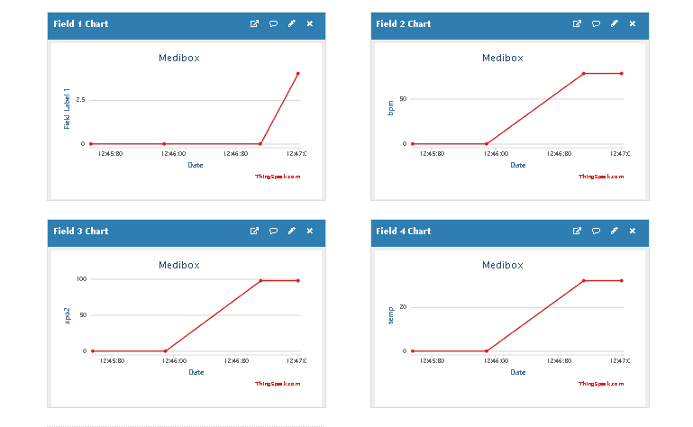

Fig: 4

Figure 4 shows the output seen in Thinkspeak. Here we can see 4 field charts. Field 1 chart represents the tablet taken or not deatails. In field 2 chart we get the details of bpm. Filed 3 chart gives details of spo2and finally field 4chart gives details of body temperature. Think speak have information like the date and time of medicine taken and temperature,spo2 and bpm checked.

**5.2 MOBILE APP**

Using the code, the system can be automated and customized in a way that the user needs.The Medibox contains login page, medication monitoring and sensor reading page, and widgets. All the data will store in an online server database.

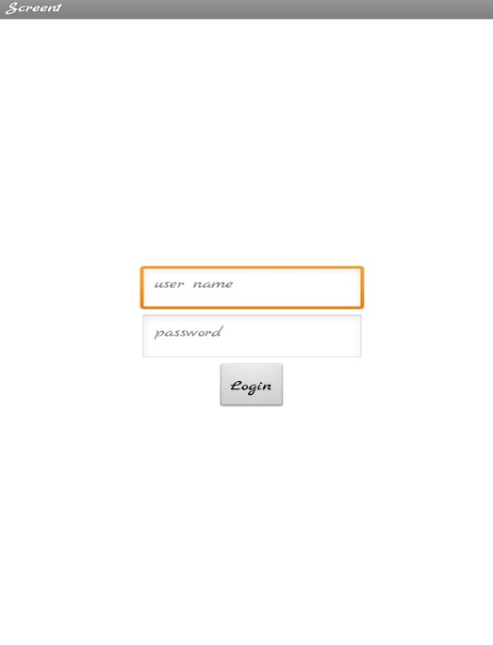

Fig 5

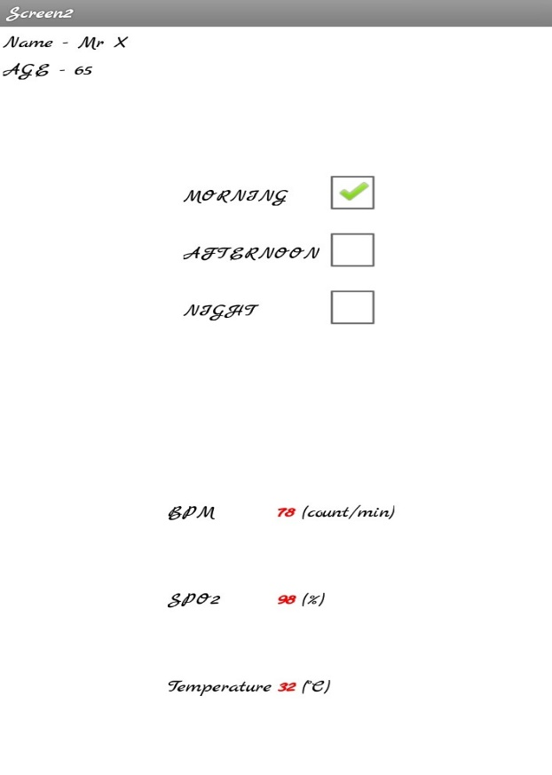

Fig 6

Figure 5 and Figure 6 are the front end of the application. Screen 1 will ask the user to enter the username and password.If both the username and password is correct, then it will direct to the screen 2 else it will shows that the username and password is invalid.Screen 2 displaces the username, age and the medicine status and sensor readings.After taking the medicine,when the patient presses the confirm switch, a green tick will be shown at the checkbox.When the user places their finger on the sensor, the corresponding readings of BPM,SPO2and Temperature will be shown on the screen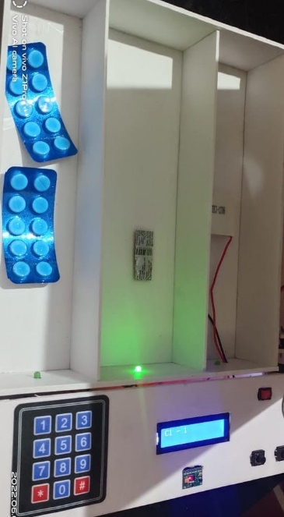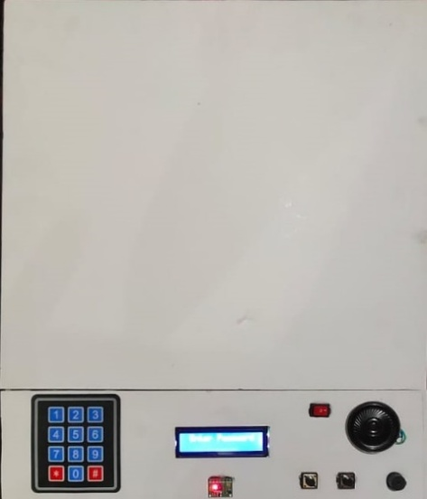

Fig 7 : Prototype model

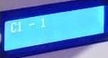

Fig 8:LCD Display

**CHAPTER 5**

**CONCLUSION**

The objective of implementing this project is to monitor the patient of all age for their proper intake of prescribed medications by doctor. One such attempt is a multipurpose intelligent device named SMARTMEDIBOX - IOT Enabled Patient Assisting device which helps the patients take their medications at the right time. In this paper, the design of aSMART MEDIBOXhas been introduced. This MediBox contains separate portions that can be programmed for different user’s needs. MediBox helps the users or take care person by specifying the required medicine quantity. MediBox takes control on alerting patient to take the medicines by giving an alarm through a buzzer and patients can take their medications at the right time.It also confirms the medicine taken by the patient. separate portions that can be programmed for different user’s needs. MediBox helps the users or take care person by specifying the required medicine quantity. MediBox takes control on alerting patient to take the medicines by giving an alarm through a buzzer and patients can take their medications at theright time. It also confirms the medicine taken by the patient.

REFERENCES

[1]MEDIBOX – IoT Enabled Patient Assisting Device MSaravanan978-1-5090-4130-5/16/$31.00 ©2016 IEEE.

[2] Marie T. Brown, MD and Jennifer K. Bussell, MD, “Medication Adherence: WHO Cares?”, Mayo Clin Proc. 2011 Apr; 86(4): 304314doi: 10.4065/mcp.2010.0575

[3] Cramer JA, Mattson RH, Prevey ML, Scheyer RD, Ouellette VL, “How often is medication taken as prescribed? A novel assessment technique”, Erratum in JAMA 1989 Sep 15; 262(11): 1472.

[4] Machine Ying-Wen Bai and Ting-HsuanKuo, “Medication Adherence by Using a Hybrid Automatic Reminder” IEEE International Conference on Consumer Electronics (ICCE), Las Vegas, USA, 2016.

[5] John K. Zao ; Mei-Ying Wang ; Peihsuan Tsai ; Jane W.S. Liu, “Smart phone based medicine in-take scheduler, reminder and monitor” 12th IEEE International Conference on E-Health Networking Applications and Services (Healthcom), 2010

[6] DeeptiAmeta, KalpanaMudaliar , Palak Patel , “Medication Reminder And Healthcare – An Android Application”, International Journal of Managing Public Sector Information and Communication Technologies (IJMPICT) Vol. 6, No. 2, June 2015 DOI : 10.5121/ijmpict.2015.6204 39

[7] VasilyMoshnyaga, Masaki Koyanagi, Fumiyuki Hirayama, AkihisaTakahama, “ Medication Adherence Monitoring System for People with Dementia”, IEEE International Conference on Systems, Man, and Cybernetics, Budapest, Hungary, 2016

[8] S. Jayanth; M B Poorvi; M P Sunil, “MED-Alert: An IoT device”, 2016 International Conference on Inventive Computation Technologies (ICICT), Coimbatore, India, 2016

[9] A Dohr ,R.Modre-Opsrian, M.Drobics ;D. Hayn ;G.Schreier, “The Internet of Things for Ambient Assisted Living,”, 2010 Seventh International Conference on Information Technology: New Generations (ITNG), Las Vegas, USA, 2010

[10] SuthatRonglong, ChaiyawutSookplang, ChonlamethArpnikanondt, VajirasakVanijja, “Design of a Medication Reminder and Feedback System for Thai Elders,”, International Conference on Computer & Information Science (ICCIS), Kuala lumpur, Malaysia, 2012

[11] Kemal Serdaroglu , GamzeUslu ; SebnemBaydere, “Medication intake adherence with real time activity recognition on IoT”, IEEE 11th International Conference 2015 on Wireless and Mobile Computing, Networking and Communications (WiMob), Abu Dhabi, UAE, 2015.